CH-7 Assignment

Part A:

Show work for ALL questions on separate sheets, then record the answers on the “Response Form”.

- What are the exact roots of the equation tan x − 1 = 0 for −π ≤ x ≤ π ?
Solution
$$tan x=1$$
but the general solutions for $tanx=1$ are:
$$x=π/4+πn$$
The solutions range for −π ≤ x ≤ π will be:
B. $x=-3π/4 ,π/4$

- What are the non-permissible values of θ for sec θ cot θ .
Solution
non-permissible values occur when the result is zero or undefined
sec θ cot θ =csc θ
csc θ=0
The non-permissible values can only be:
A. θ ≠ |  | π | + 2πk , k ∈ Z

- Which expression is equivalent to
sin(2B)
?
2 sin² B

Solution

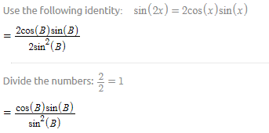
=$cotB$
Choice D

Solution
Can be rewritten as
$$\left(\frac{sinθ}{cosθ}\right)\left(\frac{sinθ}{cosθ}\right)\left(cosθ\right)\left(\frac{cosθ}{sinθ}\right)$$
$$=tanθ$$
$$choice C$$

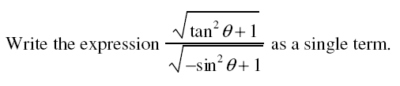
Solution

$$\frac{\sqrt{\tan^{2}{θ}+1}}{\sqrt{-\sin^{2}{θ}+1}}=$$

$$=\sec^{2}{θ}$$
$$choice B$$

- What is the exact value of the expression 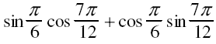
Solution
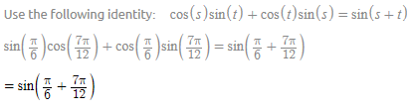
=$\sin\left(\frac{3π}{4}\right)$
$$=1/\sqrt{2}$$

Choice A

- What is the exact value of the expression? 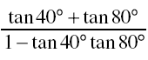
Solution
$$\frac{tan40+tan80}{1-tan40tan80}=-1.7320508$$
=$-\sqrt{3}$, choice A
- 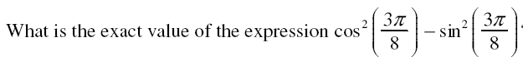
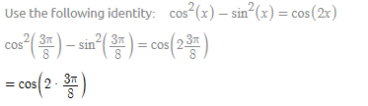
$$=-1/√2$$
$$Choice B$$

- Which expression is equivalent to $\tan^{2}{θ-\sin^{2}{θ}}$
Solution
$$\tan^{2}{θ-(1-\cos^{2}{θ)}}$$
$$\tan^{2}{θ-1+\cos^{2}{θ}}$$
=$\sin^{2}{θ\tan^{2}{θ}}$
Choice D

- What is the general solution, in radians, to the equation: sin2x+2cosx=0

Solution
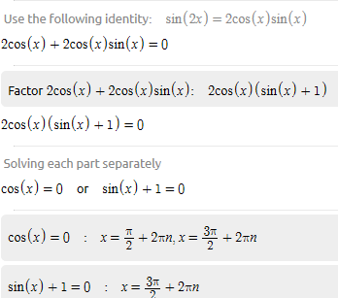

Combining all the solutions we have:
$$x=\frac{π}{2}+πn, where n∈I$$
Choice D

PART B
- What are the roots of the equation
Solution
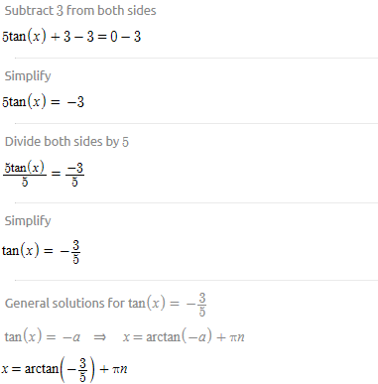

$≈{149.036}^{0}$
$$≈{149}^{0}$$

- Write the expression 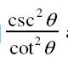 as a single term.

Solution

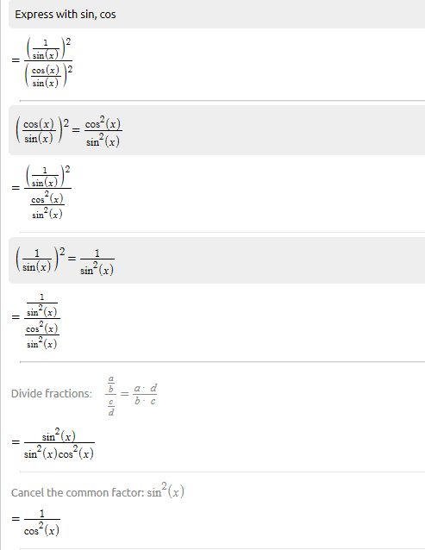

= $\sec^{2}{x}$

- Write the expression $\frac{-cosθ+secθ}{tanθ}$as a single term.
Solution

$$\frac{-cosθ+secθ}{tanθ}=\frac{-cosθ}{tanθ}+\frac{secθ}{tanθ}$$

$$=\cos{xcot+cscx}$$

- What are the exact roots of the equation sec x = 2 for 0 ≤ x ≤ 2π ?
Solution
$$x=\sec^{-1}\left(2\right)$$
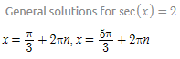
At the given interval,

$$x=\frac{π}{3} ,\frac{5π}{3}$$

- Write the expression $\frac{tanθsecθcotθ}{cscθ}$ as a single term.
Solution
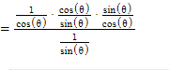
$$=\frac{sinθ}{cosθ}$$

$$=tanθ$$

- Write the expression -sec2θ −cot2θ + tan2θ as a single term.
Solution
$$= -{\left(\frac{1}{cosθ}\right)}^{2}-{\left(\frac{cosθ}{sinθ}\right)}^{2}+{\left(\frac{sinθ}{cosθ}\right)}^{2}$$
$$={\left(\frac{1}{sinθ}\right)}^{2}$$
$$=\csc^{2}{θ}$$

- Determine the exact value of sin165°.
Solution
Use identity:$\sin\left(x\right)=cos⁡(90-x)$
- $\sin\left(165\right)=\cos\left(90-165\right)$
$$=cos⁡(-75)$$
$$=\frac{\sqrt{6}-\sqrt{2}}{4}$$

- Write the expression 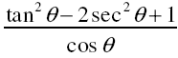as a single term.
Solution
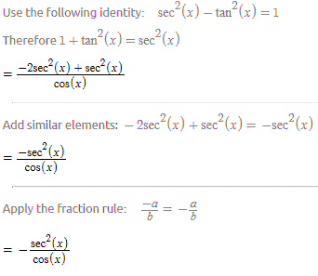
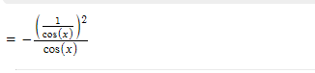
$$=-\frac{1}{cos^{3}\left(x\right)}$$

- Write the expression 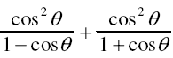 as a single term:

Solution
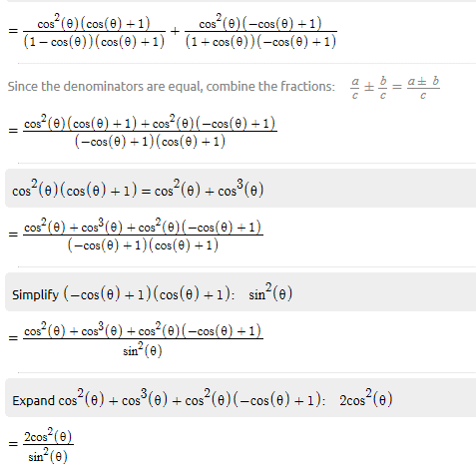
$=2\cot^{2}{θ}$

- Solve the equation −2sin x − 2 = −7sin x −1 over the domain 0 ≤ x ≤ 2π . Give the answers to the nearest hundredth.
Solution
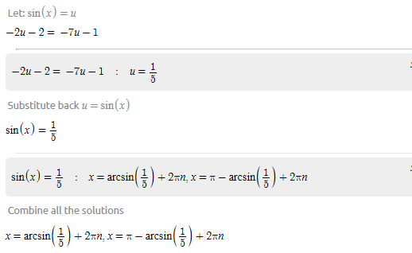
- $x≈{11.54}^{0}, {168.46}^{0}$

Part C:
- Prove the identity for all permissible values of the angle:
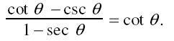
Solution

Express with sin, cos
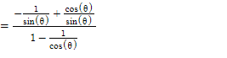
$$=\frac{cosθ}{sinθ}$$
$$=\frac{1}{tanθ}$$

$$=cotθ$$
$$Hence the proof$$

- Prove the identity for all permissible values of the angle:
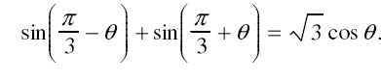
Solution
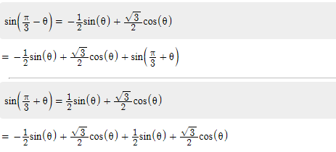
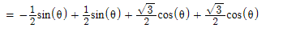
=$\sqrt{3}cosθ$
Hence the proof

- Use algebra to solve the equation −9cos2x −3cos x = −2 over the domain 0 ≤ x ≤ 360°.
Give the answers to the nearest degree.
Solution
$$let cosx=u$$
- $-9u^{2}-3u+2=0$
$$u=\frac{3±\sqrt{-3^{2}-4\left(-9\right)\left(2\right)}}{2(-9)}$$
$$=>u= -\frac{2}{3}or u=\frac{1}{3}$$
$$when cosx=-\frac{2}{3}:x=\cos^{-1}{(-\frac{2}{3})}$$
$$when cosx=\frac{1}{3}:x=\cos^{-1}\left(\frac{1}{3}\right)$$

At the given interval,
$$x≈{{{{70.53}^{0},131.81}^{0},228.19}^{0},289.47}^{0}$$

$$=>x≈{71}^{0}, {132}^{0}, {228}^{0}, {289}^{0}$$

